# CS 255 System Design Document Template

## UML Diagrams

### UML Use Case Diagram

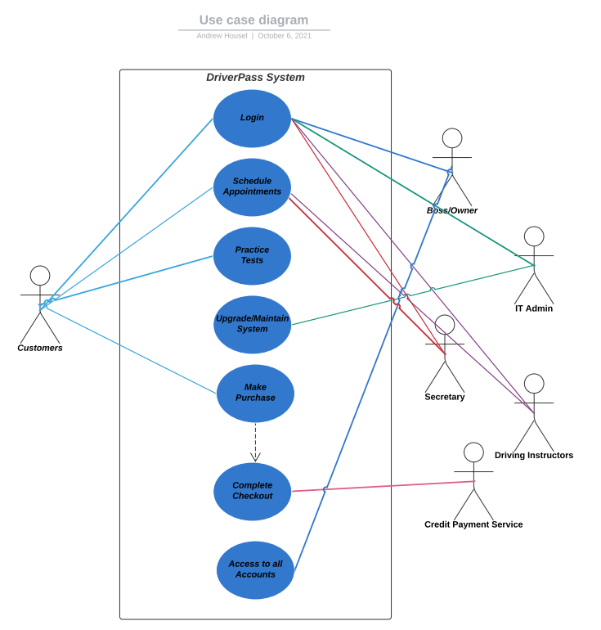

### UML Activity Diagrams

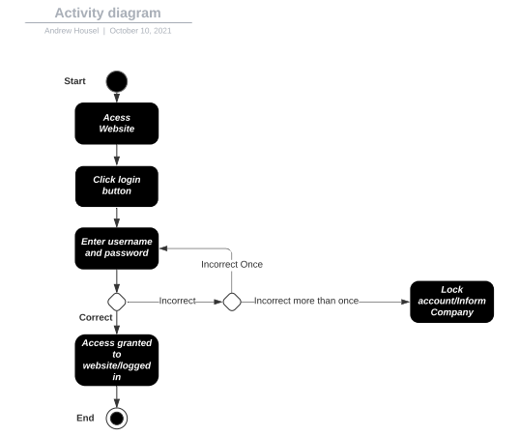

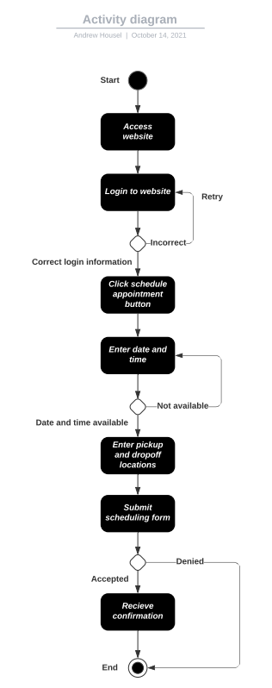

### UML Sequence Diagram

### UML Class Diagram

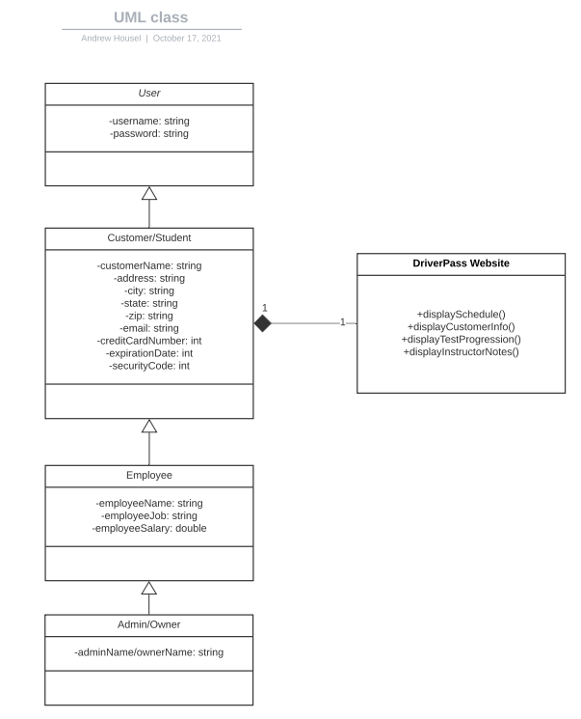

## Technical Requirements

**Hardware:**

* Computers
* Mobile Devices
* Internet
* Routers
* Cloud Server

**Software:**

* Windows operating system, most up-to-date version
* Newest security software available from the cloud
* Linked to DMV for most up-to-date guidelines
* Database to store customer information

**Tools:**

* Designers
* Developers

**Infrastructure:**

* Domain name
* Email service
* Website registration